**Project Design Phase – I**

**Solution Architecture**

|  |  |
| --- | --- |
| Date | 21-Oct-2022 |
| Team ID | PNT2022TMID03607 |
| Project Title | Corporate Employee Attrition Analysis |

**To reduce Attrition**

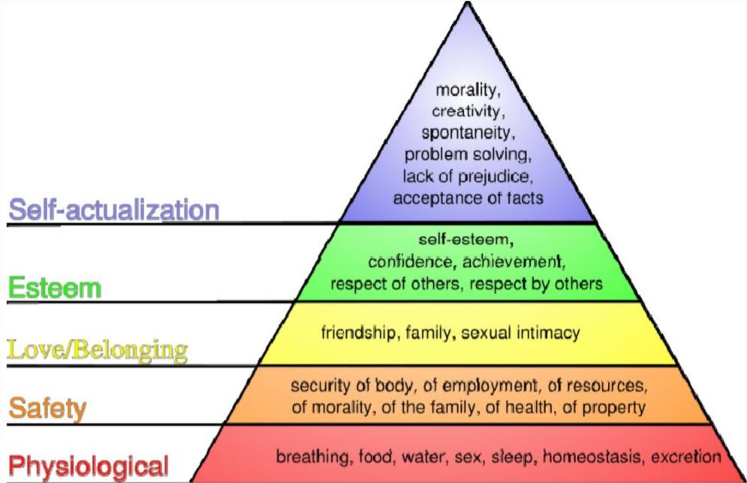

**SolutionArchitecture**

